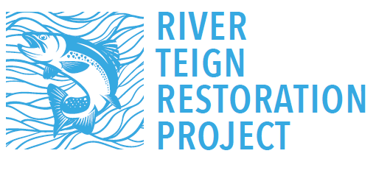

The River Teign Restoration Project is a local fish and river conservation project funded by the National Lottery Heritage Fund. Led by the Teign Angling & Conservation Association (TACA), this four year project aims to increase the numbers of salmon and sea trout returning to the River Teign and its tributaries. The project officers are Louise Davis (based in Chudleigh) and Geoff Stephens (based in Chagford).
The project has spent the past two years building up information and knowledge of the Teign, carrying out practical conservation works, conducting surveys for fish and wildlife, and working with local volunteers. The project has worked to raise awareness in the importance of the river for wildlife and the key pressures causing fish declines, and inspire local people – young and old – to take an interest in the river.
We work closely with our project partners (National Trust, Westcountry Rivers Trust, Environment Agency, MED Theatre and Peter Randall-Page), bringing their skills and experience to the project.
We have an ongoing exhibition at Castle Drogo which explains more about the project, why it was set up and shows some excellent film footage of life above and below the water of the Teign.
There are plenty of opportunities for local people to get involved, from water quality sampling to wildlife surveys, walkover assessments and spawning surveys, practical conservation work, and reporting any pollution sightings or incidents. We have over 30 trained Riverfly volunteers now, and these summer surveys help us to monitor the health of the river, observe trends over time and also pick up any sudden drop in invert levels. We have just set up our first collective group of CSI volunteers: CSI is Westcountry Rivers Trusts’ water quality monitoring scheme and allows volunteers to test water quality and input data into a central database, which helps build a really good picture of the health of the river.
Alongside the National Trust, we have been carrying out practical repair works to the riverbanks at Drogo and Fingle, and next we will be looking to carry out similar at Dunsford. Our approach is to try and create some ‘quiet zones’ along the river, which usually correspond to known salmon spawning grounds. Our aim is to reduce the number of people and dogs going into the river here. In other areas, we will be stabilising the banks for improved public access. Both approaches aim to reduce bankside erosion leading to sediment loss, and to reduce the levels of disturbance to the river in key areas.
In August and September we will be carrying out our annual electrofishing surveys, where we survey 40 sites across the Teign for salmon and trout fry. This gives us a really good indication of the success of last years spawning. We are also working with Bournemouth University who have a phd project on salmon and trout migration. By tagging some of young fish on the Teign, we can track them and work out how many make it down the river and out to sea, and how many might get stuck in river. This helps us piece together more info about the factors that may be contributing to the decline in salmon numbers. We have temperature loggers installed throughout the catchment and they are proving very useful. Last summer we recorded an in-river temperature over 20°C. Fish, in fact most freshwater aquatic life will struggle to get the oxygen they need at that level. We are fortunate that large stretches of the Teign are wooded, which has helped to keep temperatures cooler but these increased low flows and high temperatures are a very real concern.
We have been working closely with our project partners the Environment Agency to tackle a number of issues recently, including illegal discharges, damaging bankside clearance works, in-river blockages (including a trampoline!) and illegal poaching to name just a few. We always welcome any reports of anything untowards and it can be done anonymously.
We have a vast history of records from as far back as 1959 which we are using to inform our work, for example historical spawning records, fry counts, and for the last few years Riverfly data. All of this helps to build a picture about the catchment and what and where the issues are. All the data gathered by volunteers will be added to this library. One of the legacies of this project will be this digital resource which holds thousands of data records for the Teign.
Lots more info on our website and please get in touch with us, we’d love to hear from you.

