Risk assessment

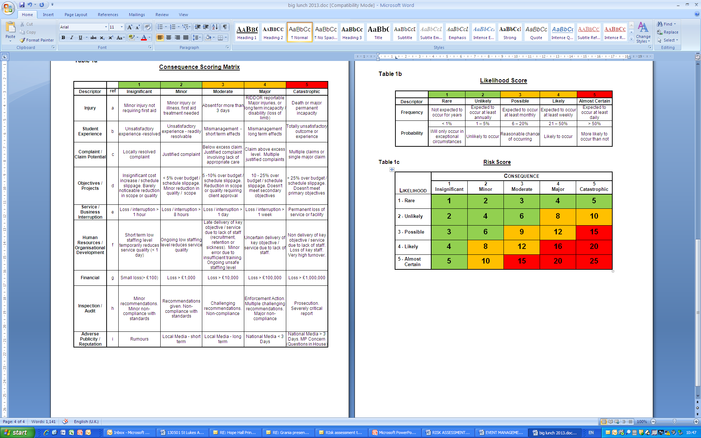

Ready to fill in Risk Assessment
nb ACT insurance covers Wildlife Wardens carrying out work specifically for wildlife where the owner of the site has given permission.
It covers Wildlife Wardens leading groups (including training and walks) who aren’t Wildlife Wardens, as long as they have taken the Leading Volunteers Course. If you feel you have previous experience and use similar risk assessment methods, please talk to us beforehand.

Narrative and main points eg what you are doing, where and with whom.
Do you, or your organisation have insurance cover?

Name: ……..

Task: Coppicing and hedge laying activity with a small group of Wildlife Wardens.

Address: ………

Insurance cover: ACT policy

Date and time: …….

Nb The Likelihood x Seriousness score should be 6 or under. If it is over 6 and no more than 12, then look for measures that will reduce the risk.
If it is over 12 then the task is too dangerous and needs to be completely re-thought.

Hazard (what might happen that hurts somebody?) | Measures taken to prevent the problem | Likeli-hood  1-5 | Serious-ness  1-5 | L X S  6 or under acceptable.  8-12 look for more measures.
Slips, Trips and Falls resulting in broken bones | Site to be checked for trip hazards prior to the task. Briefing to warn participants of uneven ground and such hazards and remind safe storage of tools and cut brash to avoid trip hazards. Volunteers to be wearing suitable sturdy boots/shoes. | 2 | 3 | 6
Plant and Fungi allergies and insect stings/bites | Pre-task brief including potential for such hazards (propensity of blackthorn splinters to become septic). All participants will be advised to wear PPE gloves to protect from thorny shrubs and irritating plants. Advise participants in advance to wear long sleeved tops and long trousers to reduce scratches and stings/bites.  Coordinator to check for known allergies at beginning of task. First aid will be available. Advise all participants to check at the end of the day for any bites, stings and unwanted visitors on their skin (ticks etc.). | 1 | 4 | 4
Weather - Exposure to extreme weather conditions may lead to sun stroke and/or hypothermia/hyperthermia | Participants advised to wear appropriate clothing. The event should be postponed if the weather forecast doesn’t look good. | 1 | 3 | 3
Cuts and abrasions | All participants will be wearing hedge laying PPE gloves when using and sharpening tools.  Check all tool heads are secure and handles are free from splinters and cracks prior to use.  Eye protection provided as required. Advise participants to wear long sleeves/trousers to minimize cuts and scratches from vegetation.  First Aid kit to be carried and notify participants of location at pre-task briefing.  Advise participants not to work too closely. | 2 | 3 | 6
Muscular – skeletal injuries  Lifting/moving layed and/or cut material may lead to muscular skeletal injuries | Briefing to include safe use of tools briefing to include standard kinetic approach to manual handling (feet comfortably apart, bend at the knee, keeping back “naturally” straight, avoid stooping/twisting/turning while carrying, keeping head up and a “relaxed” grip. Advise anyone with back pain to stop immediately.  Rotate tasks so that individuals are not training with repetitive tool use. Reduce large material to portable lengths. Lifting aids used if appropriate, such as wheelbarrows  Team lifting used if appropriate. Suitable footwear is required- no open toes | 1 | 3 | 3
Pathogens | PPE gloves and equipment used when litter picking,  Dog mess to be bagged up and disposed of in dog bin and use spade to remove from work area. No eating or drinking during task, Anti-bacteria hand gel provided and remind participants of good hygiene methods prior to food breaks. | 1 | 3 | 3
Fire Spreading and Burns | Fire only to be lit on a clear site with no overhanging trees and considering possible changes in wind direction.  An adequate supply of water to be on hand.  Fire to be extinguished before leaving the site | 2 | 3 | 6

