Risk assessment

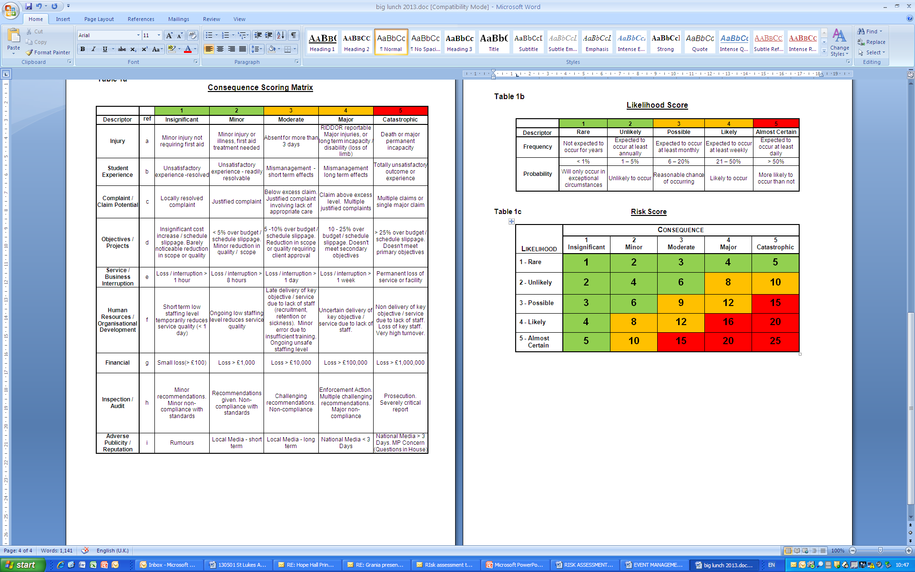

Ready to fill in Risk Assessment
nb ACT insurance covers Wildlife Wardens carrying out work specifically for wildlife where the owner of the site has given permission.
It covers Wildlife Wardens leading groups (including training and walks) who aren’t Wildlife Wardens, as long as they have taken the Leading Volunteers Course. If you feel you have previous experience and use similar risk assessment methods, please talk to us beforehand.

Narrative and main points eg what you are doing, where and with whom.
Do you, or your organisation have insurance cover?
Setting up and manning, alongside other ACT members, ACT’s Wildlife Warden stand at the Turn the Tide event on Dawlish Lawn on 2nd June 2022.

ACT has Personal Liability insurance for all of its members.
Hazard (what might happen that hurts somebody?) | Measures taken to prevent the problem | Likeli-hood  1-5 | Serious-ness  1-5 | L X S  6 or under acceptable.  8-12 look for more measures.
Back injury from lifting heavy items (gazebo, tables, etc.). | - Make sure that all volunteers know that they should ask for help when lifting heavy items.  - Keep an eye on volunteers to make sure that they are not lifting items dangerously.  - If someone is lifting items dangerously, take them aside and explain how they can do it safely. | 1 | 4 | 4
Slips, trips and falls caused by trip hazards. | - Check the site for uneven ground before setting up the stall. Make sure to point out hazards to volunteers.  - Ask all volunteers to keep stall equipment out of the way, and to be aware of what is going on around them. | 2 | 2 | 4
Collapse of stall/objects falling off stall causing injury | - Keep all display items pinned down in case of wind.  - Double check that the gazebo, tables and chairs have been erected correctly.  - Make sure that display boards are stable.  - Keep a close eye on any children who are handling skulls/interested in the display. Ask them to be careful if it looks like they might accidentally knock over the display. If needed, ask parents to intervene. | 1 | 3 | 3
Adverse weather – sun burn, dehydration, feeling cold and wet etc. | - Ask volunteers to bring appropriate clothing for the weather.  - Sun cream/hat and water in case of warm/sunny weather.  - Warm clothes and waterproofs in case of cold/wet weather. | 2 | 2 | 4
Adverse weather - damage to display | - Make sure that all stall items are pinned down in case of strong winds.  - Keep display under cover if rain is likely.
Spread of Covid 19 and other infectious diseases. | - Supply hand sanitiser for volunteers and members of the public to use when handling display items.  - Ask stall volunteers not to turn up if they are feeling very unwell or have tested positive for Covid 19. | 2 | 2 | 4
Engagement with the public – verbal or physical aggression. | - Always remain polite and avoid getting into confrontational situations.  - Try to de-escalate any confrontational situations.  - Move away if any concerns for personal safety | 1 | 2 | 2
Collision with vehicles when setting up and taking down stands. | - Make sure that all volunteers are aware that there are moving vehicles on site.  - Ask drivers to drive slowly and sensibly if they are not doing so. | 1 | 5 | 5

